## Line integral of a scalar function

(failed to find good examples)

Find the electrical field on the axis of symmetry of a non-uniformly charged ring.

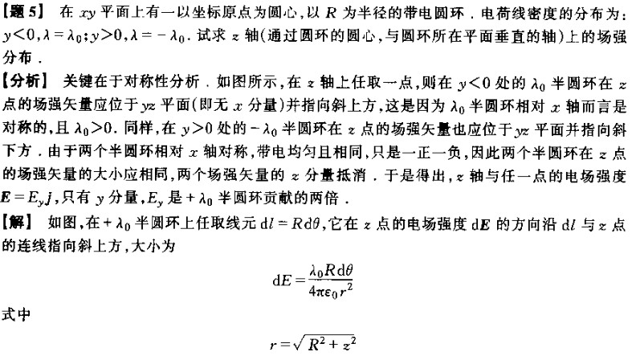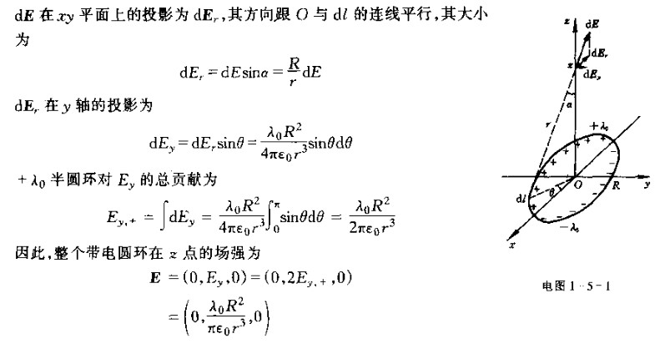

Find the magnetic field at the focus of an elliptic/hyperbolic current (use polar coordinates)

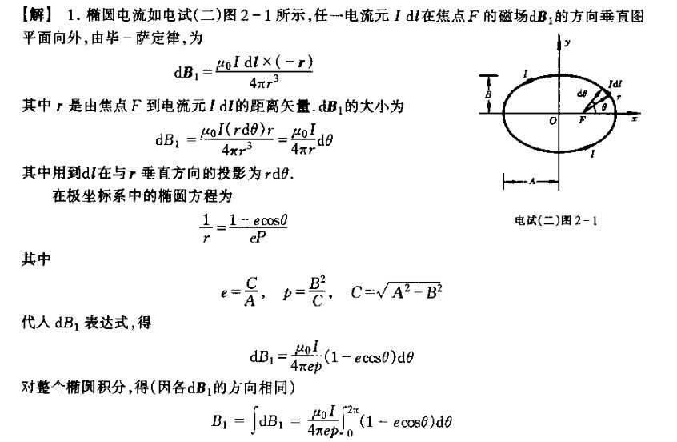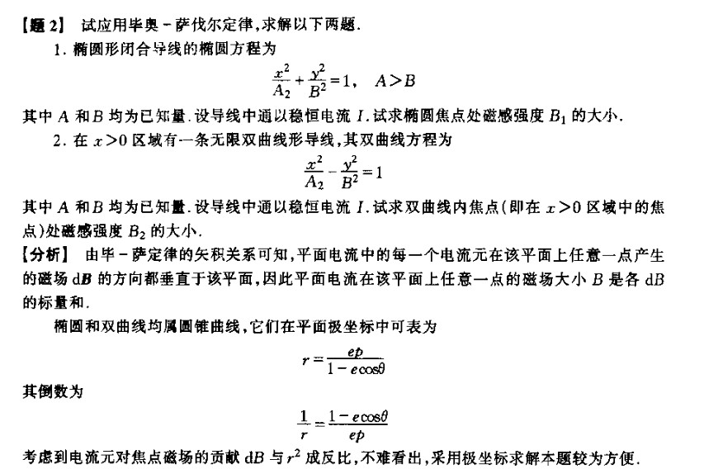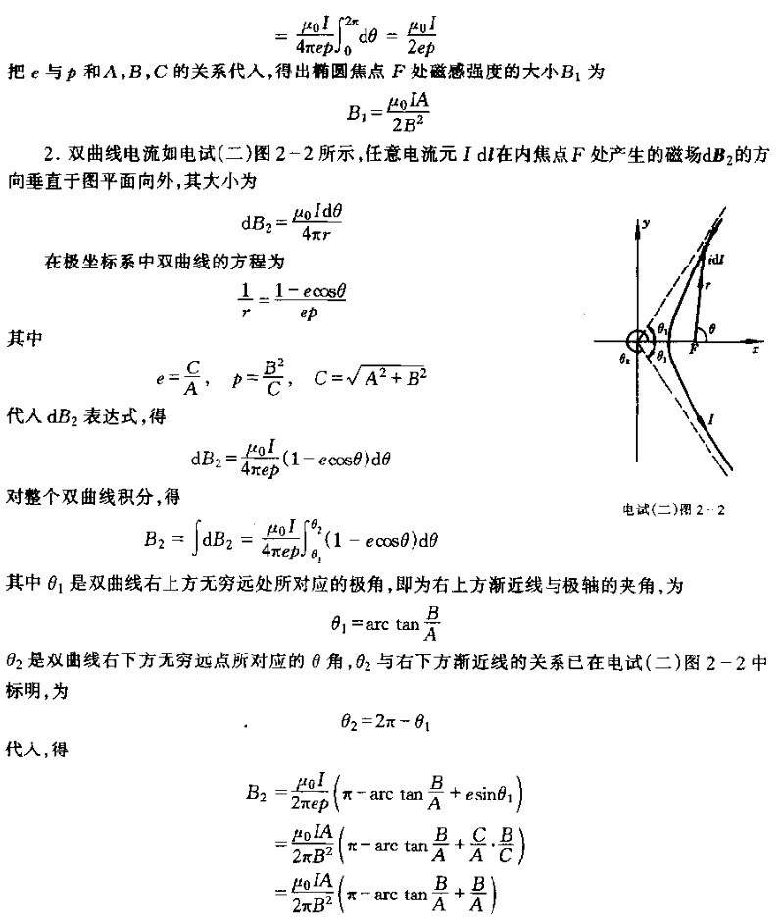

## Line integral of a vector function (*Work* in physics)

###### Examples from VP160: Honors Physics

Find the work done by some force field on a particle

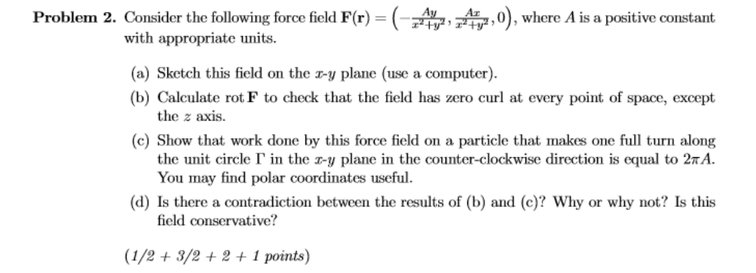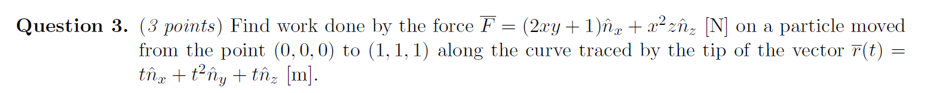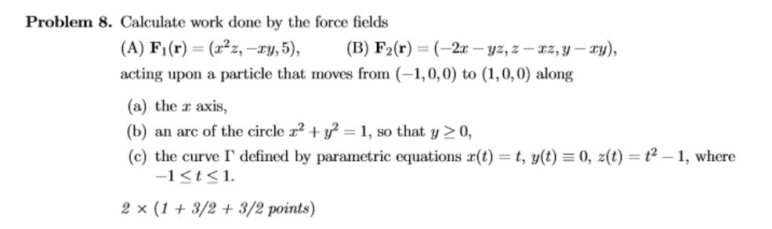

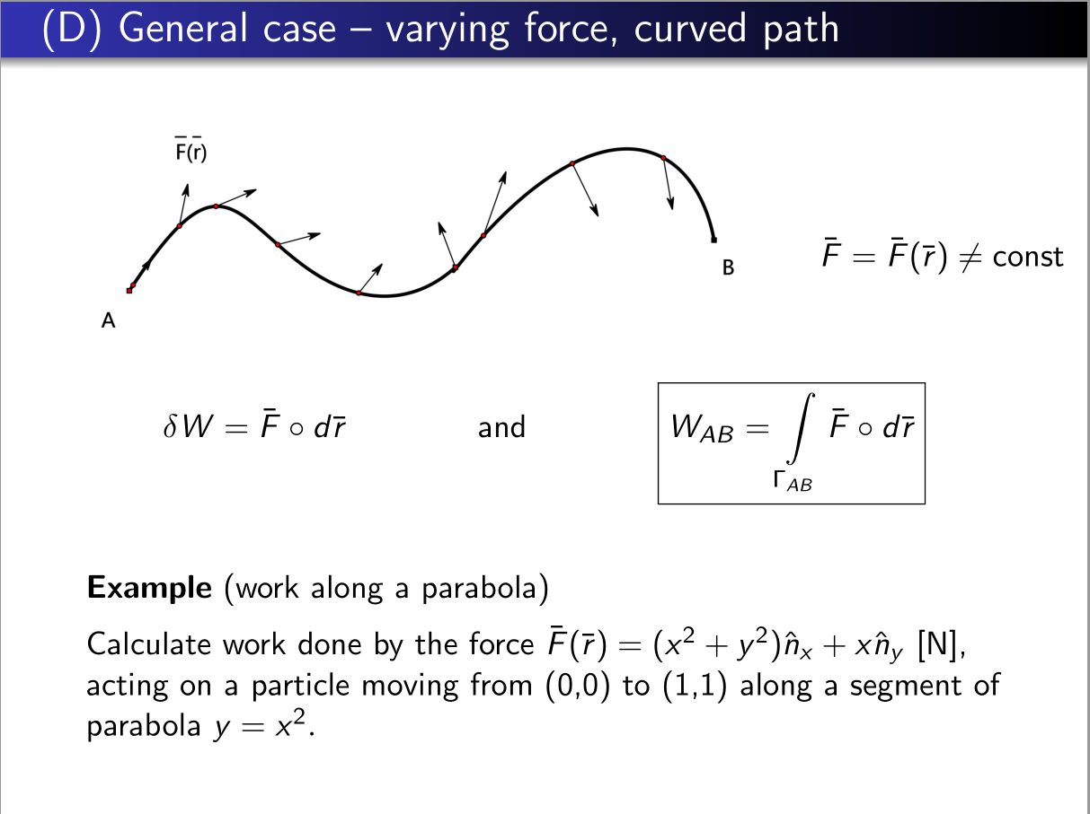 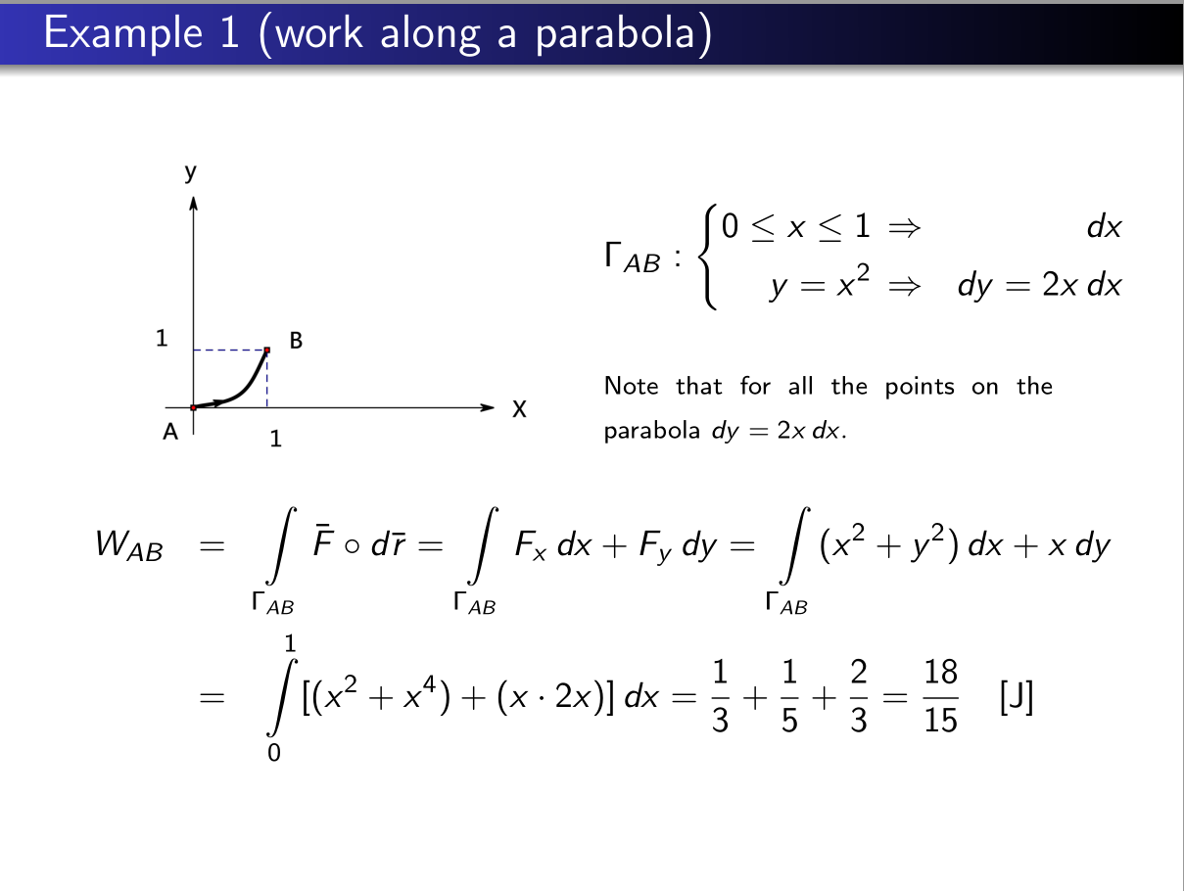

(From VP160 course slides)

###### Examples from VE230: Introduction to Electromagnetics

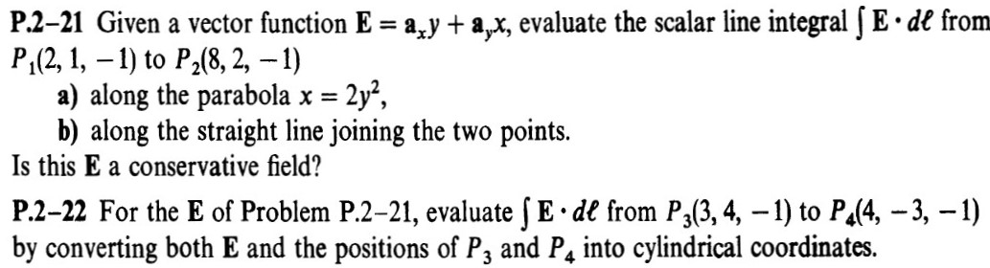

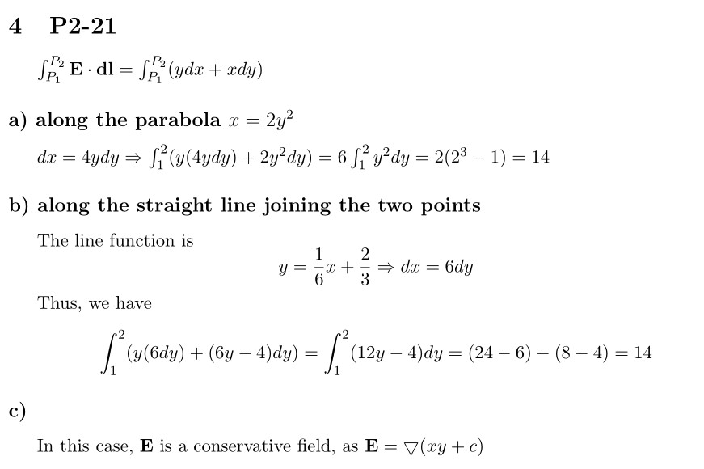

From VE230 homework

###### 3D curve

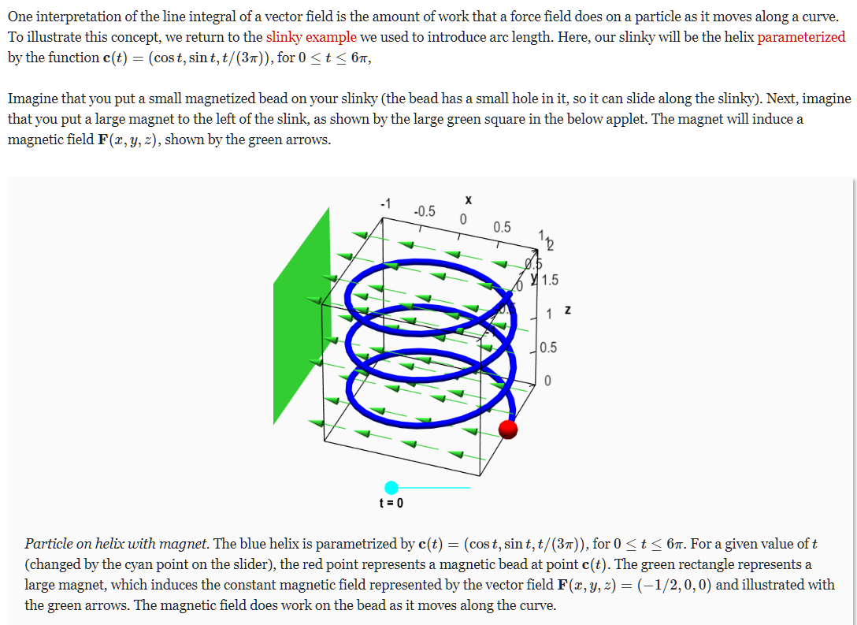

<https://mathinsight.org/line_integral_vector_field_introduction>